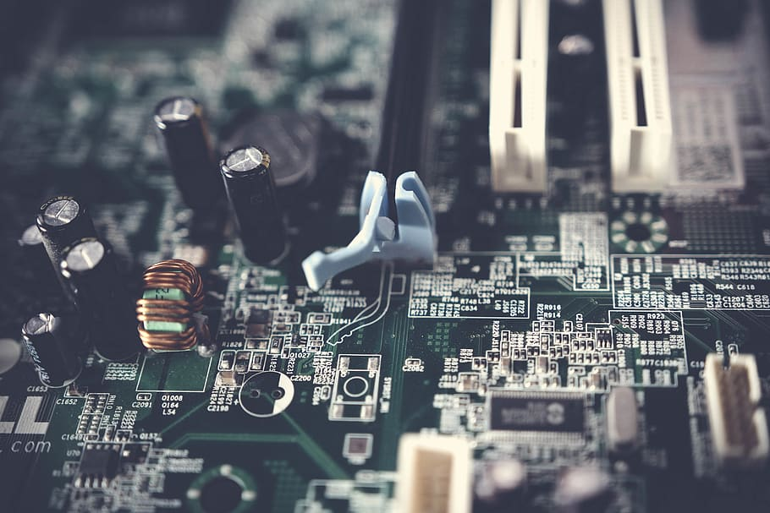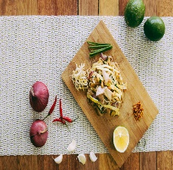

Programs offerd

Computer hardware

Mobile repairing

Banking

Beauty & wellness

Computer science

Legisties

Natural farming market connect

Two wheeler repairing

Mpobile journalism



Literacy India community collage (LICC)

Limited Seat

WWW.Literacyindia.org

Session starts from

January 2024

Contact no. 8588853380

Register NOW